|  |
| --- |
| Software Engineering Lab |
| SRS Document |
| Software Component Cataloguing Software |
|  |
| **120CS0124** |
| **Maloth Aditya** |

|  |
| --- |
| Assignment 1 |

**Table of Contents**

1. **Introduction ………………………………………………………………………………………… 2**
   1. **Purpose ……………………………………………………………………………………………… 2**
   2. **Scope …………………………………………………………………………………………………. 2**
   3. **Environmental Characteristics ……………………………………………………………. 2**
   4. **Definitions ………………………………………………………………………………………….. 2**
   5. **References ………………………………………………………………………………………….. 3**
   6. **Overview of Developer’s responsibilities …………………………………………….. 3**
2. **General Description ……………………………………………………………………………… 3**

**2.1 Product Perspective …………………………………………………………………………….. 3**

* 1. **Product Functions Overview ………………………………………………………………… 3**
  2. **User Characteristics …………………………………………………………………………….. 4**
  3. **Operating Environment ……………………………………………………………………….. 4**
  4. **General Constraints …………………………………………………………………………….. 4**

1. **Functional Requirements ……………………………………………………………………… 5**
2. **External Interface Requirements ………………………………………………………….. 9**

**4.1 User Interfaces …………………………………………………………………………………….. 9**

**4.2 Hardware Interfaces …………………………………………………………………………….. 9**

**4.3 Software Interfaces ……………………………………………………………………………. 10**

1. **Performance Requirements ………………………………………………………………… 10**

**5.1 Capacity Requirements ………………………………………………………………………. 10**

1. **Design Constraints ……………………………………………………………………………… 10**

**6.1 Software Compliance …………………………………………………………………………. 10**

**6.2 Hardware Limitation …………………………………………………………………………. 10**

1. **Conclusion ………………………………………………………………………………………….. 11**
2. **Introduction**

The software cataloguing software provides a centralized and organized system for managing software resources within an organization. The software allows users to easily

* 1. **Purpose**

SCCS is a tool for organizing and managing software components within an organization. The purpose of this document is to help users on how to interact with the software and know its features, and to help the developers on what technologies to be used for the development of this software. SCCS is deployed on a website domain [*www.software-catalogue.com*](http://www.software-catalogue.com) (this site is not functional yet, site development is under progress)

* 1. **Scope**

The cost of developing and maintain large and complex computer software systems are immense and can take up a significant share in an organization’s revenue. SCCS solves this by managing your organization’s software components. SCCS aims to help the busy employees and organizations manage their soft wares and software components.

* 1. **Environmental Characteristics**

SCCS interacts with the components that are stored in the server and holds details of the components which are potentially reusable. The reusable components can be either design or code.

* 1. **Definitions**

This section contains the abbreviations, acronyms that would be used later in this document.

SCCS – Software Component Cataloguing Software

HTML – Hyper Text Modelling Language

CSS – Cascading Style Sheets

JS – JavaScript

SQL – Structured Query Language

* 1. **References**

There are few words like ‘we’, ‘our’ that refer to SCCS or SCCS company employees. And words like ‘you’, ‘your’ refers to SCCS users.

For additional references:

* A [*Software components catalogue*](https://ifs.host.cs.st-andrews.ac.uk/Research/Publications/Papers-PDF/1985-89/SWCompCatalog86.pdf%20) by Ian Sommerville and Murray Wood
  1. **Overview of Developer’s responsibilities**

The developers of SCCS should design a simple interface for the software and implement an optimized code for the various functionalities of the software. Developers should implement the features that are demanded by the users in an optimized approach.

1. **General Description**
   1. **Product Perspective**

SCCS improves the efficiency of organizations by managing the reusable components. This software replaces the manual effort of many employees that manage reusable components and save their potential time which can be utilized in optimizing other code of the organization.

* 1. **Product Functions Overview**

This section contains graphical overview of the data flow among different functions and components of SCCS. The flow of data or information is visualized by few diagrams like use case diagrams, data flow diagrams, sequence diagrams and activity diagrams.

The below use case diagram visualizes various functions that are added in SCCS in brief. A customer (User or Admin) can login/sign up to interact with SCCS interface and then do different tasks like adding new software components, updating catalogue, checking the status of catalogue or generate reports for the software components.

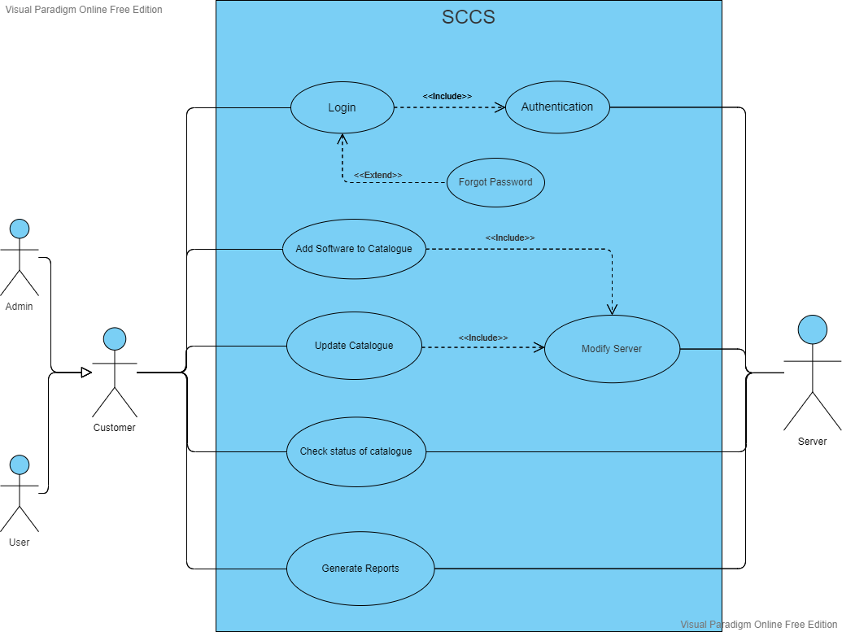

* 1. **User Characteristics**

SCCS follows simple design for its interfaces. So that most users cannot find difficulty in running this software. But users need certain knowledge about how to upload and download a file, and how to edit the file virtually.

* 1. **Operating Environment**

SCCS requires operating systems and devices that can render large and complex websites and softwares.

Operating System: Linux/Windows/Macintosh/Android

SCCS interacts with the local storage of user’s personal computer upon user’s approval and stores software and software components onto the software server.

* 1. **General Constraints**

SCCS is deployed as a website, so the cost to develop and maintain would be less than that of other deployments. Main aim of this software is to achieve maximum features that are desirable by users in optimum cost and time.

The expected budget for design and development can be around $100 for a single iteration of software update, and maintenance of this software would cost up to $1000-5000 yearly for low customer base and can go up to $30000 yearly.

1. **Functional Requirement**

The various functions that help in managing SCCS are:

* User login and authentication
* Search software components by keywords or categories
* Add new software components to the catalog
* Edit and delete existing software components
* Assign software components to specific projects or users
* Manage the dependency of the software component and check the compatibility of the component with the existing system
* Generate reports on software components usage and inventory.

Some of the functionalities may exist till date in the software, and some may be still in the development phase.

SCCS has 2 types of accounts to run smoothly. Admin account (or cataloguer account) and user account. Admin can be the head of the organization and users can be the employees of that organization. Admin can also be a user.

***Admin account privileges***:

* Admin can enter components in the catalogue
* Delete any of the components from catalogue
* May associate reuse information with a catalogue component in the form of a set of key words.

***User account privileges***:

* User can query about the availability of a component using certain key words to describe the component.
* Browse the components in each category.

**User Login**

This function deals with the authentication of user and the logging them into SCCS website. User or Admin enter his/her details to login/signup.

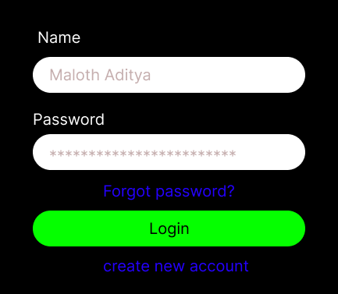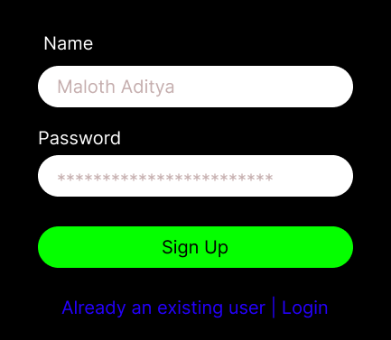

If the user/admin is a new customer then he needs to create account for SCCS.

Details required for signup:

1. Your name
2. Your email address
3. Your password

If the user/admin is an existing customer then he needs to login to access SCCS.

Details required for login:

1. Your name/email address
2. Your password

Authentication algorithm runs in the background and matches the entered details with the SCCS database. Upon successful authentication, you get to see the SCCS interface. If the authentication is not successful, the user is prompted to login again using correct credentials. If there are multiple unsuccessful attempts, the user’s account will be blocked for 10 days. This duration may increase upon further unsuccessful attempts on login. Authentication and Blocking are done to ensure security against unauthorized access and data breaches.

**Search Software Component**



This function searches the given input among the existing set of software catalogues present in the server.

Details required for searching of software component:

1. A software component name to search

If the given software component name matches with any of the values present in the database, then a list of all matched results should be shown below the search bar.

If the search results in failure, then an error message pops up below the search bar.

**Add New Software Components**

This function adds a new software component to the existing list of software components.

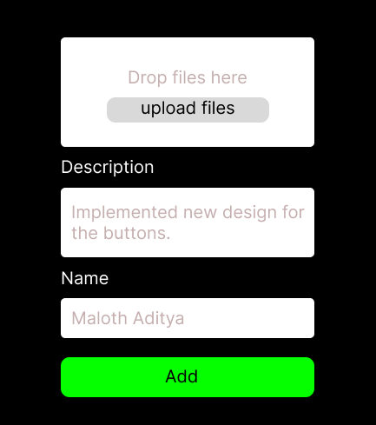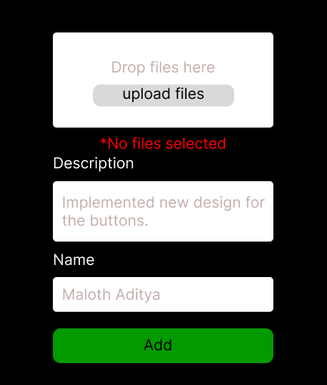

Details required for adding a new software component:

1. File to be uploaded
2. Description
3. Name of the person who uploaded it

The server gets updated upon successful addition of new software component to the SCCS. If there is any error while addition of the new component, this function throws error.

**Modify Software Components**

This function modifies the server by editing, deleting or by updating the already present software components.

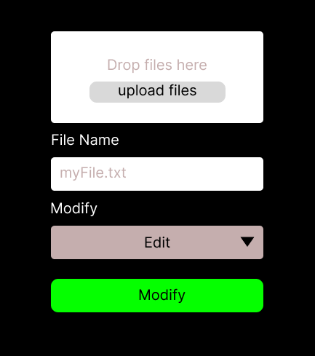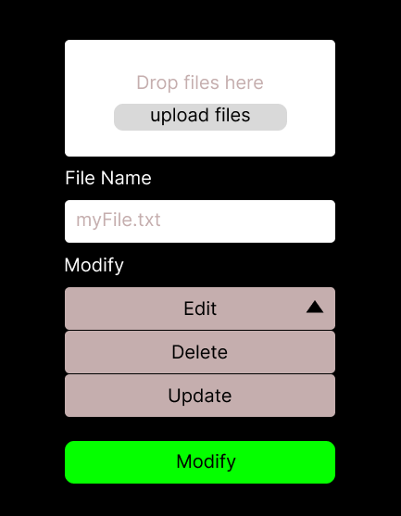

Details required for modification of a software component:

1. Software component name
2. Modify option (Edit, Delete, Update)

The server gets updated upon successful modification of the software component.

**Generate Reports**

This function generates reports for the software components present in the database.

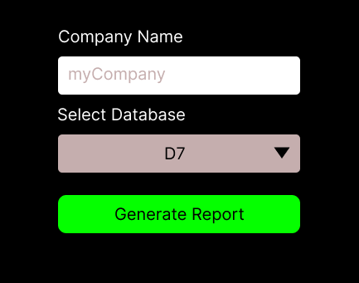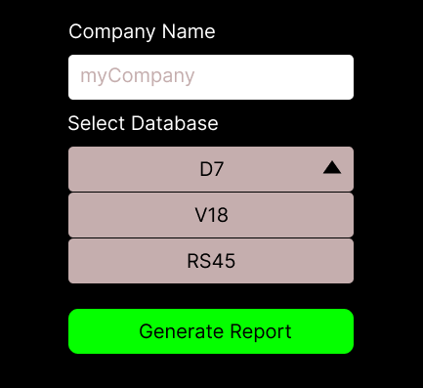

Details required for generating reports:

1. Enter company name
2. Select database

Reports get generated and are shown on the website upon successful execution of this Generate reports function.

1. **External Interface Requirements**
   1. **User Interfaces**

The user interface of SCCS is easy for any new person to understand. This section helps them in understanding the interface and the terms used in the website.

* 1. **Hardware Interfaces**

SCCS requires certain hardware support to run smoothly.

* A stable internet connection
* A device that supports uploading and managing large files
* At least 2GB of decent RAM space (this prevents cloggy loading of SCCS website on the device)
* The device on which the SCCS runs should be able to compile and render some software technologies like React.js
  1. **Software Interfaces**

SCCS requires some software assistance for it to run smoothly.

The SCC software should be web-based, allowing access from any device with a web browser. The software should be developed using latest web technologies such as HTML5, CSS3 and JavaScript, and modern frameworks like ReactJS or AngularJS. It should use a relational database such as MySQL or PostgreSQL for data storage and data manipulations.

1. **Performance Requirements**
   1. **Capacity Requirements**

SCCS database can hold data of N users and can run smoothly for any file of size less than 10 GB. The database of this software is designed to handle up to 10K user’s login at the same time, smoothly.

1. **Design Constraints**
   1. **Standards Compliance**

SCCS follows certain standards for smooth conduct of the software.

Some primary security compliance mandates include:

* Payment Card Industry Data Security Standard (PCI DSS)
* Data Protection law
* International organization for Standardization (ISO) standards

We follow the rules of the government of the country that we are located in. We allow all types of users to use the software, there are no limits of age, gender, and nationality. We strive hard to avoid duplicate versions of this software.

Once you store any information on your local device that is linked to this software, we backup the data to our servers upon users’ approval. The data on our servers is highly encrypted according to Data Protection Law. All the payment details of user are stored in our servers upon users’ approval. We strictly data privacy of our users.

* 1. **Hardware Limitations**

SCCS has few hardware limitations. Since SCCS is a complex software and requires at least 2 GB of free RAM and sufficient online/cloud storage. The online storage should be greater than at least greater than 1 GB so that the user can easily upload files and manage them. If user has no online storage, then he/she can use his/her personal storage to store files and then link these files to SCCS.

1. **Conclusion**

We have described all the features that are implemented in SCCS. If a user reads till here continuously then he/she would have got clear idea of all the features and the interface of SCCS, and if any developer reads till here then he/she would have got idea on what technologies to use and what frameworks to be used in developing the SCCS.

We would strive hard to implement other new features that are demanded by our users, and our developers would be striving day and night to develop a software that fulfills user’s demands.